Help to complete the tasks of this exercise can be found on the chapter 1 ” Values, types and operators”, chapter 2 “Program structure” and chapter 4 “Data Structures: Objects and Arrays” of our course book “Eloquent JavaScript” (3rd edition) by Marijin Haverbeke. The aims of the exercise are to become familiar with JavaScript basics, especially values, types, arrays, and operators. The student will also learn what kinds of structures a JavaScript program has, and how the flow of the program is controlled.

Embed your theory answers, drawings, codes, and screenshots directly into this document. Always immediately after the relevant question. Return the document into your return box in itsLearning by the deadline.

It’s also recommendable to use Internet sources to supplement the information provided by the course book. Especially the * marked task can require that.

The maximum number of points you can earn from this exercise is 10 + 1 = 11.

Tasks:

**1. Answer the questions? (4 * 0,25 = 1 point):**

* 1. What is the result and why?

**10 == ‘10’**

On totta, koska löytyy samankaltainen arvo. JavaScript vertailee niitä vain arvon perusteelle, ei tietotyypijen mukaan.

* 1. What is the result and why?

**12 === ‘12’**

On epätosi, koska === vertaa myös tietotyyppejä, ja numero ei ole sama kuin merkkijono.

* 1. What is the result and why?

**typeof “Kissa”;**

Tämä palauttaa string, joten tulos on merkijono

* 1. What is the value of the variable currentPort and why?

let port = 3001; let currentPort = port || 3000;

currentPort saa arvon 3001, koska portti on määritelty ja se on totta. Jos portti olisi epätosi tai määrittelemätön, currentPort olisi 3000.

**2. JavaScript boolean values. (2 * 0,5 = 1 point)**

a. Are the following values true or false in JavaScript? Use a browser console and program an if-else statement to find the answers.

true, false, 9, -0.7, 0, ‘kissa’, ‘’, ”“, null, undefined, {}, [], [0,1]

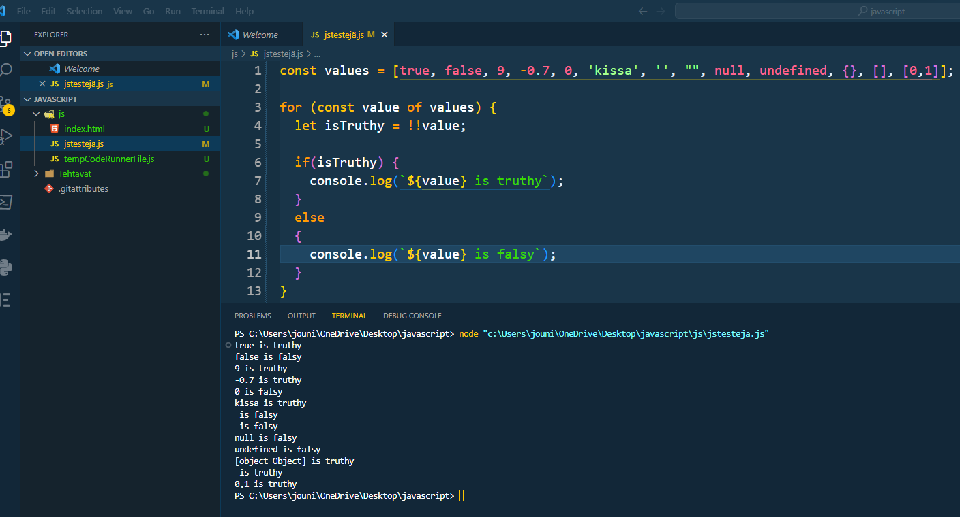

b. Why?

**3. Strings. (4 * 0,5 = 2 points)**

In JavaScript, you can use single quotes, double quotes, or backticks to mark strings.

a. Are there any differences between these differently marked strings?

b. Catenate two literal strings with a variable. Give two different ways to do it. The end result should be following: I have 36.5 euros. Please note that the amount is from the variable, the text parts are literals.

c. Give reasons to use the character \ inside strings.

d. Give three practical examples of different String methods. Please take care that you include taking a substring and converting the entire string to lowercase into your examples.

Where did you find that information?

**4. Variables and constants. (1 point)**

a. What does it mean that JavaScript variables have no external datatype?

b. What happens if you do not remember use either of the keyword let (or var) when defining a variable? (0,25 points)

c. Is there any differences between the keywords var and let when defining a variable? (0,5 points)

d. How do you define a constant in JavaScript? (0,25 points)

**4. Looping in JavaScript. (2 * 0,5 = 1 point):**

Let’s use the array distances = [ 164, 526, 248, 12, 81, 181, 34 ].

a. Use a basic for loop to calculate the sum of the distances. (0,5 points)

b. Use another kind of a for loop to calculate the same sum . (0,5 points)

**5. Considering JavaScript arrays. (4 * 0,25 = 1 point)**

a. Can an array contain both numbers and objects at the same time in JavaScript?

b. Explain what it means to 1) modify an array in place or to 2) return a modified copy of an array. Give one example of a JavaScript method that modifies an array in place, and one example of a method that returns a modified copy.

c. What does it mean that a JavaScript array is mutable? *

d. You have a following code clip. How many arrays do you have in the memory at the end?

let array1 = [1,3,5];

let array2 = array1;

**6. Working with JavaScript arrays (2 points)**

Let’s use the array distances = [ 164, 526, 248, 12, 81, 181, 34 ].

a. Write a code clip that returns the length of the array. (0,5 points)

b. Write a code clip that adds the distances 8, 533 and 76 at the end of the array and in this order. Use one of the array methods. (0,5 points)

c. Write a code clip that removes the number 248 from the array in place. Use an array method. A tip: One of the methods to consider could be splice. (0,5 points)

d. Clone the array distances to the variable distances_duplicate. Use ES6 way: The spread operator. * (0,5 points)

Please, search also the Net to get help.

**7. Working with JavaScript Array methods filter, map and reduce (2 points) \***

These JavaScript methods are heavily used in modern JavaScript applications.

Let’s use the array points = [ 64, 56, 48, 12, 81, 91, 34, 19, 95, 55 ].

a. Return a new array into a variable called enough_points. The new array contains all numbers of the original array points that are at least 40. Use the method filter. (0,5 points)

b. Return a new array into a variable called grades. The new array contains the grades that are calculated from the numbers of the original array points. Use the method map. The evaluation scale is the following: at least 40 points -> 1; 50 -> 2; 60 -> 3; 70 -> 4; 85 -> 5. Otherwise, the grade is 0. (0,5 points)

c. Calculate the average grade by using a method reduce. Use the original array points. (0,5 points)

d. Explain shortly in purposes of the above methods. (0,5 points)

Please, search the Net to help.